THE IMPACT OF COVID-19 ON MARKET RETURNS VOLATILITY: EVIDENCE FROM HO CHI MINH CITY STOCK EXCHANGE
Tang Chan Thieng
College of Economics, Can Tho University, Vietnam
Email: tangchanthieng@gmail.com
Truong Dong Loc
College of Economics, Can Tho University, Vietnam
Email: tdloc@ctu.edu.vn
ABSTRACT
This study aims to investigate the effects of COVID-19 pandemic on the volatility of market returns for the Ho Chi Minh City Stock Exchange (HOSE) over the period from 22nd January 2020 to 31st December 2021. Using the Autoregressive Distributed Lag (ARDL) bounds test approach, the empirical results reveal both short-term and long-term effects of COVID-19 cumulative cases on the volatility of market returns. Specifically, in the short-term, the cumulative cases of COVID-19 have significant negative effects on market returns volatility. However, in the long-term, the empirical findings show a positive relationship between the number of COVID-19 cases and the market volatility.
Keywords: ARDL; COVID-19 pandemic; market returns; HOSE
1. INTRODUCTION
It has been two rough years of COVID-19 pandemic. The world has experienced how a crisis related to the social health problem would affect international economies in the context of globalization. The spillover effect from one country to another led to limitations and closures of nations’ borders as well as trading activities. According to the IMF, the world’s GDP had declined 5.2% at the end of 2020, while Europe and the USA, those countries suffered the most from the COVID-19 pandemic, had witnessed their worst recession in the last decade.
Going through four phases of COVID-19 spreading over the period from 22nd January 2020 to the end of 2021, Vietnam has been proving itself as one of the most successful nations in Asia for combating and controlling the widespread of the novel pandemic. Back to the early stage of 2020, when Vietnamese and the Government confronted the very first waves of COVID-19 outbreak before applying and following the social distancing measures, stock market indices (VN-Index and HNX-Index) had beared the most unexpected and adverse plunge in recent years. For instance, VN-Index had dropped from 1,000-point milestone to nearly 600 points whilst HNX-Index lost its over-100-point peak and went down to under 90 points at the end of March 2020. Speaking of the Ho Chi Minh City Stock Exchange – the largest Stock Exchange in Vietnam regarding to the number of stock listed and daily trading volumes, it is clear to observe the market returns volatility during phases of COVID-19. Anh and Gan (2020) , by researching Vietnam stock market under the impact of COVID-19 pre-lockdown and lockdown, proved that daily COVID-19 confirmed cases negatively affected stock returns during the first wave of the pandemic but thank to the efficient measures of the Government, the market remarkably recovered when the lockdown directives were put into practice, claiming positive influences on stock performance of the entire market and different business sectors in Vietnam. Similarly, within panel data of stock returns of 733 companies listed on Ho Chi Minh City Stock Exchange (HOSE) and Hanoi Stock Exchange (HNX), Hung, Hue, and Duong (2021) expanded the timeframe in their study to cover the second wave of COVID-19 pandemic in Vietnam, also concluded the negative impact of the number of daily COVID-19 infected cases on market returns, especially for the second wave, compared to that for the lockdown period.
As a matter of fact, the short-term effects of COVID-19 pandemic on Vietnam’s market returns are absolutely concrete in researches, yet, there appears a gap in which we might consider about the lack of discovering a long-term linkage between COVID-19 infected cases and the volatility of market returns in Vietnam’s stock market. Evidently, studies across nations have been made to show how global stock markets respond to COVID-19 in the long run due to the rising number of infected cases and deaths (by COVID-19). The results from studies may be various according COVID-19 situation in each country, for example, Chaouachi and Slim (2020) used ARDL cointegration approach to show that COVID-19 confirmed cases are responsible for the decrease in the value of the trading volume of Tadawull All shares index in long-run. Rabhi (2020) found negative impacts of reported COVID-19 confirmed cases and news related to deaths to the stock markets performance of the emerging Asia stock markets. On the other hand, Wardani and Lahuddin (2021) indicated that COVID-19 infected cases insignificantly affected trading volume of the Indonesia Stock Exchange by applying ARDL model with daily series data.
Therefore, this study sets a goal to figure out whether COVID-19 in response to Ho Chi Minh City Stock Exchange in respect of market returns volatility in both short-term and long-term by applying Autoregressive Distributed Lag (ARDL) model proposed by Pesaran, Shin, and Smith (1996) in order to demonstrate short-term and long-term dynamics of market returns and COVID-19 cumulative infected cases. Furthermore, the quantitative model also includes Brent crude oil price, Vietnam’s national gold price and USD/VND exchange rate in order to endorse the control variables. The time frame used in this study lasts from 22/01/2020 to 31/12/2021 so as to cover four waves of the pandemic in Vietnam.
2. LITERATURE REVIEW
On 11th March 2020, WHO officially claimed that COVID-19 was a global pandemic (WHO, 2020). However, when it comes to the COVID-19 negative impacts on one of the most crucial channels for capital in economies, namely the stock market, many countries had already encountered the increasing risks derived from the early uncertainty atmosphere that triggered investors’ fear as news involved in infected cases confirmed in China and the outside world kept boarding. Comparing to the impacts of historical pandemics such as Spanish Flu, SARS-2003, MER-2012 or EBOLA-2014 on economies in numerous nations, which have been affirmed by several authors (Chen, Chen, Tang, and Huang (2009); Barro, Ursúa, and Weng (2020); Koubâa (2020), COVID-19 genuinely and adversely affected the global stock markets in various aspects since the vast spreading of the coronavirus seems to transfer faster from one country to another in accordance with the development of transportation facilities along with global trading activities. The stock markets themselves reflect the health of economies, hence, if such an economy is in a peril status, the market volatility may demonstrate the uncertainty, and the extent of stock returns probably fluctuate in a larger interval.
Chaudhary, Bakhshi, and Gupta (2020) used GARCH model to estimate the volatility of 10 stock markets, suggested for the global market, came up with the findings that COVID-19 negatively impacted market returns during January to June 2020, on top of that, market returns volatility remained higher after the second quarter of the COVID-19 period despite a bounce back appeared for all market indices. Likewise, by applying the GARCH model in researching for Asian stock markets, Sharma (2020) revealed that markets reacted diversely to the spread of COVID-19 due to some different situations in the host countries. It is evidently stated that there is a relationship between COVID-19 pandemic and global market volatility at the beginning of the first COVID-year.
In 2021, the number of confirmed cases and deaths as a result of SARS-CoV-2 virus was predictably rocketing, very soon a recorded figure of 280 million infected cases and over 05 million deaths was set at the end of 2021 (WHO, 2021). Those are to feature the pandemic itself was still something that put the world on the verge of a crisis once again, just like what happened in 2020.
Fortunately, with all-round measures to stand against the widespread of the rising pandemic, many nations have basically gained control of the COVID-19 pandemic. Trading activities were re-established, international borders reopened and stock market indices around the world setting new peaks and attracting exceeding flows of capital and number of investors. It was tremendous and unforeseen that global stock markets would reclaim for such a precise length of time. Alfaro, Chari, Greenland, and Schott (2020) by parametric model analysis found the rebound of the US stock market when the evolution of the pandemic was not detrimentally expected. The result is quite comparable with Phan and Narayan (2020) as their study argued that stock markets of 25 countries over reacted to the unexpected news about COVID-19, but when information became available and people understood the ramifications more broadly, the market corrected itself. In addition, Uddin, Chowdhury, Anderson, and Chaudhuri (2021) with the panel data analysis of 30 countries hit by COVID-19 concluded the disparate effects of COVID-19, yet those fizzled out over time. Gherghina, Armeanu, and Joldeș (2021) took place in Romania to compare the impacts of COVID-19 with the financial crisis (2007-2009) on the volatility of stock returns and revealed that COVID-based volatility approximately corresponded to that of the financial crisis. This influence was clearly pointed out in the first quarter of 2020 but quickly faded after two next quarters. Moreover, when seeking for the influences of COVID-19 through specific periods, Duttilo, Gattone, and Di Battista (2021) applied data from January 2016 to December 2020 for numerous stock markets in Europe finally discovered that confirmed cases in the first wave of COVID-19 had gloomy effect on markets performance, yet after two waves of the spreading in Europe, the effect was less dramatical. Along with COVID-19 factors (cases and deaths), some facets have been brought into studies involved in stock returns movement and have been proved to be drivers of the markets during COVID-19 circumstances. Specifically, by diving into research of net oil-importing Asian countries, Prabheesh, Padhan, and Garg (2020) focused on the relationship between stock returns and oil price returns within the COVID-19 periods. The results from the DCC-GARCH model for daily series data showed that there was a co-movement between oil price returns and stock returns during the context of COVID-19, signaling that falling oil prices acted as a negative indicator for the stock markets. In the same spirit, Rabhi (2020) concluded that oil price, gold price and exchange rate as control variables in a panel data ARDL approach were found to be determinants of Asian stock markets during the studied period of COVID-19 pandemic.
In Vietnam, researchers suggested that the Government measures ultimately gained positive consequences on the bounce back and growth of the economy (Ha et al., 2020; Van Nguyen et al., 2020). Concerning to stock market, Nguyen, Hai, and Nguyen (2021) with regression of panel data for HOSE and HNX proved that COVID-19 had significantly negative effects on stock returns and liquidity, denoting that servere influences of COVID-19 pandemic left short-run uncertainty on stock market. Nevertheless, after employing the Government’s imposition of lockdown, the market performance highly recovered and yielded positive and significant outcomes. This conclusion accords with the results of Anh and Gan (2020) and Hung et al. (2021). However, as Thiều and Xuân (2021) investigated COVID-19’s effects on stock returns of 15 banks listed on HOSE using event study method, the results in short-term determined that the daily growth of COVID-19 confirmed cases, significantly decrease banks’ stock returns, yet, a long-term linkage may be questioned.
It seems that COVID-19 did have some short-term effects on Vietnam stock market, then again, we may consider the conclusion of Chương (2020) that the pandemic possibly causes some dreadful consequences to the economy unless there is an efficient approach for a long-term struggling. This corresponds to the inquiry of Singh and Shaik (2021) whether the bounce back would remain strong or COVID-19 pandemic would augment the long-term volatility on global stock markets.
All things considered, this study intends to examine short-term and long-term influences of COVID-19 cumulative cases on market returns volatility in Vietnam in order to contribute to extending past findings of research on the relationship between COVID-19 and Vietnam stock market performance. Hence, the workframe refers to capturing four waves of COVID-19 outbreak in Vietnam, namely from 22nd January 2020 to 31st December 2021, and by taking market returns volatility as the main subject, this study tries to demonstrate a transparent extent of the uncertainty and risks of Vietnam stock market.
3. DATA AND RESEARCH METHODOLOGY
3.1 Data sources
The study selects daily series data consisting of the VN30-Index taken according to the close price at the end of the days from Vietstock finance database (https://finance.vietstock.vn), since VN30 is the first portfolio of 30 large caps on HOSE, it is trustfully a solution for investors looking for a suitable market index regarding of market capital and trading volume that perfectly reflects the movement of the market. A pandemic factor which is the cumulative confirmed cases is gathered from Wordometers (https://www.worldometers.infor), and three control variables: Brent crude oil price, national gold price and USD/VND exchange rate are collected on Fiinpro database (https://www.fiinpro.com). The periods of all data are from 22nd January 2020 to 31st December 2021.
3.2 Research methodology
Data observations are calculated to fit in the quantitative method. Specifically, this paper uses the formula for daily market returns in the line with (Bora & Basistha, 2021; Chaudhary et al., 2020; Gherghina et al., 2021):
$R_{t}=ln\left(\frac{P_{t}}{P_{t-1}}\right)$ (1)
Where $R_{t}$ stands for the return of stock index/ asset price in period $t$, $P_{t}$ is the stock index/ asset price in period $t$, $P_{t-1}$ is the stock index/ asset price in the $t$-1 period.
Researchers have suggested that the market volatility describes risks and the uncertainty of market returns in a specific length of time. Given that highly shown in market volatility means the market returns moves in a larger range of values, otherwise, the market itself is in a stable status (Baillie & DeGennaro, 1990; French, Schwert, & Stambaugh, 1987). Indicators as the market volatility has been chosen to predict risk-diversification and make investment decisions for decades. One of the approaches to calculate market returns volatility is by using variances or standard errors of a time series data. This is based on the principle of quantifying daily yields of the stock market, implying that volatility reflects the degree of changes in market returns. Meanwhile, variances depict the dispersal of profit across average values, thus, the estimation of volatility refers to variances being estimated in a given length of time.
Eventually, the GARCH model developed by Bollerslev (1986) is adopted to estimate the volatility of market returns as in prior studies (Kasman, Vardar, & Tunç, 2011; Lê, 2020; Nguyen et al., 2021). The GARCH model $\left(p,q\right)$ has the following form:
$y_{t}=μ_{t}+ε_{t} \sim N\left(0,σ_{t}^{2}\right)$ (2)
$σ_{t}^{2}=c+\sum_{i=1}^{p}{α_{i}ε_{t-p}^{2}}+\sum_{j=1}^{q}{β_{j}σ_{t-q}^{2}}$ (3)
with $c>0$ and $α_{i}≥0$, $β_{j}≥0$.
It can be seen that the conditional variances of random perturbations depend on the historical values of shocks and on the values of the variances in the past. The coefficients of $σ_{t-q}^{2}$ represent the persistence of volatility, whereas the coefficients of $ε_{t-p}^{2}$ point out the degree of reaction of volatility to shocks in the market. This illustrates that VN30-Index’s volatility, which is the dependent variable used in the research model, is extracted from the conditional variances of the GARCH(1,1) process as in equation (3).
To analyze short-term and long-term effects of COVID-19 pandemic to the volatility of Vietnam stock market, this study uses the ARDL (Autoregressive Distributed Lag) model proposed by Pesaran, Shin, and Smith (2001). The general model is given as following equation:
$${∆VOL}_{t}=β_{0}+\sum_{i=1}^{p}{β_{1i}∆{VOL}_{t-i}}+\sum_{j=0}^{q1}{β_{2j}∆{lnCOV}_{t-j}}+\sum_{k=0}^{q2}{β_{3k}{∆OIL}_{t-k}}+$$
$$+\sum_{l=0}^{q3}{β_{4l}{∆GOLD}_{t-l}}+\sum_{m=0}^{q4}{β_{5m}{∆EX}_{t-m}}+λ_{0}{VOL}_{t-1}+λ_{1}{lnCOV}_{t-1}+$$
${+ λ}_{2}{OIL}_{t-1}+λ_{3}{GOLD}_{t-1}+λ_{4}{EX}_{t-1}+μ_{t}$ (5)

In the equation (5), $β_{0}$ is the constant; $β_{1}$ and $β_{2}$, $β_{3}$, $β_{4}$, $β_{5}$ are the short-run coefficients; $λ_{0}$, $λ_{1}$, $λ_{2}$, $λ_{3}$ and $λ_{4}$ are the long-run dynamics; $μ_{t}$ is the error term.
The process of running an ARDL model is stated as successive steps:
First, checking for optimal lags of each variable in the model. In this study, the Akaike Information Criterion (AIC) is applied for this stage.
Second, calculating the “Bound test to cointegration” based on Fisher statistic on the hypothesis
H₀: $λ_{0}=λ_{1}=λ_{2}=λ_{3}=λ_{4}=0$. The existence of the long-run dynamics between variables can be certified by rejecting H₀, implying the presence of cointegration in the model. If the value of F-statistic is higher than the upper bounds of the critical value I(0) this study rejects the null hypothesis, claiming that there appears the long-term relationship, otherwise, it is accepted if the F-statistic is lower than the lower critical value I(0), saying that there exists only short-term linkage between variables.
Finally, after determining whether the existence of the long-run relationship obtained in variables, the ARDL model with defined lags to test for the short-term linkages between them or the Error Correction Model (ECM) based on ARDL method with cointegration phenomenon should be performed.
The ECM model has the following equation:
$${∆VOL}_{t}=β_{0}+\sum_{i=1}^{p}{β_{1i}∆{VOL}_{t-i}}+\sum_{j=0}^{q1}{β_{2j}∆{lnCOV}_{t-j}}+\sum_{k=0}^{q2}{β_{3k}{∆OIL}_{t-k}}+$$
$$+\sum_{l=0}^{q3}{β_{4l}{∆GOLD}_{t-l}}+\sum_{m=0}^{q4}{β_{5m}{∆EX}_{t-m}}+{γECM}_{t-1}+μ_{t}$$
(6)

List of variables used in this study is presented as below:
TABLE 1. DEFINITIONS OF VARIABLES USED IN THE MODEL
Variables | Description | Formula
VOL_{t} | VN30-Index’s volatility | Conditional variances extracted from GARCH(1,1)
lnCOV_{t} | Natural logarithm of the daily total confirmed cases | $${Log}_{e}({TOTAL}_{t})$$
OIL_{t} | Returns of Brent crude oil price | $$\frac{{Brent crude oil price}_{t}-{Brent crude oil price}_{t-1}}{{Brent crude oil price}_{t-1}}$$
GOLD_{t} | Returns of nation gold price | $$\frac{{Nation gold price}_{t}-{Nation gold price}_{t-1}}{{Nation gold price}_{t-1}}$$
EX_{t} | Returns of USD/VND exchange rate | $$\frac{{USD/VND exchange rate}_{t}-{USD/VND exchange rate}_{t-1}}{{USD/VND exchange rate}_{t-1}}$$
Source: Author’s own work
The ARDL approach, according to Pesaran et al. (2001), has been proved to enclose many advantages compared to other cointegration tests. Those are:
- ARDL does not require a large number of observations.
- It allows variables used in research to have the mixture of integrations or in the same level of integrations. However, it is noted that no variable could be stationary at the second level, or I(2).
- OLS technique could be associated with the ARDL method so that, in testing cointegration, the simplification of the process is endured.
- Unlike the VAR (Vector Autoregressive) approach which only accepts endogenous variables, the ARDL model is practically approved for either endogenous or exogenous variables.
After all, this study applies some diagnostic tests for robustness analysis, including Breusch-Godfrey serial correlation LM autocorrelation Test of errors, the heteroskedasticity Test of ARCH-LM effect and the stability test of CUSUMSQ Test.
4. EMPIRICAL RESULTS
4.1 Descriptive statistics of sample
Descriptive statistics of the retained sample are presented in Table 2.
TABLE 2. DESCRIPTIVE STATISTICS
Variables | Observations | Mean | Minimum | Maximum | Standard Deviation
VOL_{t} | 488 | 0.0002 | 0.0001 | 0.0010 | 0.0002
lnCOV_{t} | 487 | 8.3647 | 0.6931 | 14.3643 | 3.2336
OIL_{t} | 487 | 0.0012 | -0.3449 | 0.3427 | 0.0400
GOLD_{t} | 487 | 0.0007 | -0.0667 | 0.0732 | 0.0081
EX_{t} | 487 | -0.0001 | -0.0152 | 0.0045 | 0.0009
Source: Summarized outcomes on Stata14
Summation of VN30-Index’s volatility known as market returns volatility included 488 observations with the minimum value of 0.0001 and 0.0010 of the maximum, denoting that during COVID-19 context, the market witnessed such a wide range of oscillation. Similarly, COVID-19 cumulative cases variable, in the form of logarithm, captures considerable standard deviation, implying Vietnam has gone through several phases of COVID-19 outbreak with different levels of seriousness, from the minimal number of confirmed cases in 2020 to over one million infected cases in 2021.
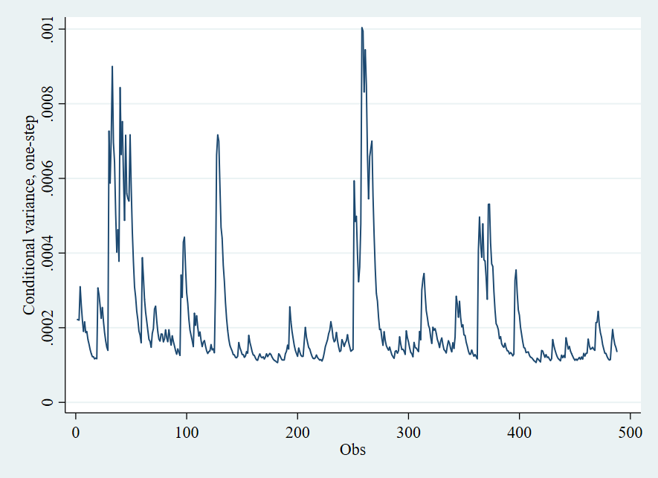
Source: Author’s own work on Stata14
Figure 1. Market returns volatility from 22nd January 2020 to 31st December 2021
Figure 1 illustrates the conditional variances of market returns, represented for the volatility of VN30-Index. It evidently confirms that market returns have experienced high levels of returns’ fluctuation during particular periods whilst COVID-19 was spreading through Vietnam. Meanwhile Figure 2 below shows how COVID-19 cumulative cases are related to the market volatility since the periods of exceeding growth in infected cases cope with those of market returns volatility.
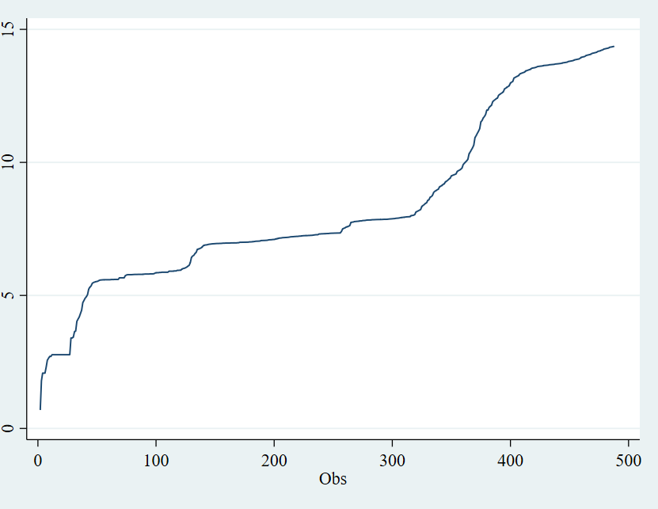
Source: Data from Worldometers and outcomes from Stata14
Figure 2. Logarithm of daily COVID-19 cumulative cases from 22nd January 2020 to 31st December 2021
For the control variables of the returns of Brent crude oil price, returns of national gold price and returns of USD/VND exchange rate, the descriptive statistics show that their movements of returns are clearly disparate. Specifically, with the standard deviation value of 0.04, the returns of Brent crude oil price display a higher level of variation compared to the returns of nation gold price and USD/VND exchange rate, those with 0.008 and 0.0009 at standard deviation values respectively.
4.2 Results of unit root tests
Even though ARDL does not require every variable to be in the same integration order, the Unit root test must be applied to make sure that no variable stations exist at the second order. Augmented Dickey Fuller – ADF (Dickey & Fuller, 1981) approach is used to test for stationarity of VOL_{t}, lnCOV_{t}, OIL_{t}, GOLD_{t}, EX_{t}. The results are presented as below.
TABLE 3. RESULTS OF ADF UNIT ROOT TESTS
Variables | Without trend | With trend
VOL_{t} | -5,127* | -5,314*
lnCOV_{t} | -2,502 | -2,376
1st difference of lnCOV_{t} | -23.568* | -23.487*
OIL_{t} | -21.810* | -21.795*
GOLD_{t} | -19.684* | -19.709*
EX_{t} | -22.643* | -22.800*
*: statistically significant at 1% level.
Source: Author’s own work on Stata14
The panel shows that all variables: VOL_{t}, OIL_{t}, GOLD_{t}, EX_{t} are stationary at I(0) in both cases without trend and trend added, except for lnCOV_{t} which has the integration order of I(1). Thus, it can be inferred that all variables used in this research are qualified for ARDL cointegration test.
4.3 ARDL bounds test for cointegration
We use the Akaike Information Criterion (AIC) in order to choose the optimal lags structure for the ARDL approach. Table 3 shows variables’ optimal lags, ranging from 0 (t) to 4 (t-4).

TABLE 4. OPTIMAL LAGS BY AIC
Variable | VOL_{t} | lnCOV_{t} | OIL_{t} | GOLD_{t} | EX_{t}
Lags | 3 | 4 | 4 | 4 | 0
Source: Output from Stata14
To examine the presence of cointegration between researched variables in this study, the Bound test approach is taken by the proposal of Pesaran et al. (2001) as mentioned above. The results of the cointegration test are as follows.
TABLE 5. BOUND TEST COINTEGRATION RESULTS
Variable | Optimal lags | F-Statistics
VOL_{t} | 3 | 13.53*
Lower critical value I(0) at 1% level significance |  | 2.45
Upper critical value I(1) at 1% level significance |  | 3.52
*: statistically significant at 1% level.
Source: Author’s own work on Stata14
The F-statistics is shown to exceed the upper critical bound value I(1), thus, it can be implied that the null hypothesis is rejected and the existence of a long-run relationship between the volatility of VN30-Index and the cumulative COVID-19 cases, the return of Brent crude oil price, the return of national gold price and the return of USD/VND exchange rate in the periods of 22nd January 2020 to 31st December 2021 is statistically confirmed.
That has given evidence for displaying short-term and long-term dynamics within variables as a consequence of an ECM model based on ARDL approach.
4.4 ARDL estimation on short-run and long-run effects
TABLE 6. THE ESTIMATED SHORT-RUN AND LONG-RUN COEFFICIENTS
Variable | Coefficient | t-statistic
Short-run relationship
Constant | 0.0000386 | 3.79*
ΔVOL (t-1) | 0.0929935 | 2.12**
ΔVOL (t-2) | 0.0699554 | 1.64
ΔlnCOV | 0.0000382 | 0.60
ΔlnCOV (t-1) | -0.0000955 | -1.48
ΔlnCOV (t-2) | 0.0005277 | 8.19*
ΔlnCOV (t-3) | -0.0001668 | -3.64*
ΔOIL | 0.0002672 | 1.77***
ΔOIL (t-1) | 0.0001516 | 1.19
ΔOIL (t-2) | 0.0002316 | 2.29**
ΔOIL (t-3) | 0.0001085 | 1.45
ΔGOLD | -0.0026322 | -3.87*
ΔGOLD (t-1) | -0.0017011 | -2.88*
ΔGOLD (t-2) | -0.0009826 | -2.05**
ΔGOLD (t-3) | -0.0012768 | -3.57*
ECT (t-1) | -0.1509102 | -6.78*
Long-run relationship
lnCOV | -0.0000117 | -1.97**
OIL | -0.0024398 | -2.00**
GOLD | 0.0180020 | 3.11*
EX | 0.0017276 | 0.08
*, ** and ***: statistically significant at 1%, 5% and 10% level successively.
Source: Author’s calculation from Stata14
Results show, in short-run periods, especially day (t-2) and (t-3) that the total confirmed cases can raise and reduce the volatility of VN30-Index, referred to as the Vietnam stock market’s volatility, by having a positive and negative significance at 1% level successively. This, indeed, is a proof of how the market over reacted in the early stage of COVID-19 pandemic as mentioned in studies of Ashraf (2020), Camba and Camba Jr (2020), Al-Awadhi, Alsaifi, Al-Awadhi, and Alhammadi (2020). The stock price moved unpredictably, making investors’ trading strategies more risky than ever. This situation explains how investors fear about the economic activities and to what extent COVID-19 would keep harshly affecting market returns. It can also be observed that while exchange rate has no effect on the movement of VN30 stock index during the context of pandemic, the returns of oil price and gold price do have some contradictory influences on it. The nonexistence of the effect of USD/VND exchange rate on VN30-Index’s volatility in the context of COVID-19 could be due to the implementation of 2016 exchange rate mechanism in Vietnam in order to deal with unanticipated shocks on the financial market. With the positive significant short-term relationship between market volatility and oil price returns, it means that any fluctuation in oil price can force the stock index to sway in a larger interval. In fact, gold is still ever a shelter for investors when facing financial shocks by carrying out negative significances, implying that the growth of gold price helped reduce the volatility of stock market since the flow of capital from stock market would move to gold market when investors apportion their portfolios’ assets. The co-movement of oil price and stock markets in the world during COVID-19 has been analyzed by Prabheesh et al. (2020), and the stabilized effect of gold as a commonality on stock market has also been proven by Trương (2014), Singhal, Choudhary, and Biswal (2019), Rabhi (2020).
This study finds that, in long-term relationships, the increasing cumulative COVID-19 confirmed cases has its effects gradually settled down, showing the negative significance at 5% level for lnCOV variable. In other studies about COVID-19 pandemic in Vietnam, the bounce back of stock market has been predicted by many researchers (Anh & Gan, 2020; Hung et al., 2021; Nguyen et al., 2021) after investigating the circumstances in the beginning of the pandemic, yet recent situation is noticeable when the number of infected cases has risen once again (Vietnam Ministry of Health, 2022), making it harder to fully handle the COVID-19. Therefore, the results in this study about the long-term effect of COVID-19 on the volatility of VN30-Index has shown that, in a optimistic way, COVID-19 would not be an alarming threat in the future regardless of the growth of confirmed cases. That circumstance would be thanks to the improvement of health service and the cover of COVID-19 vaccination. Furthermore, this paper also affirms that Brent crude oil price, and national gold price are eventually market determinants in the context of COVID-19 pandemic in the long-run.
The ECM (t-1) corresponds to the lagged error from the long-term equilibrium equation. The coefficient reflects the speed of variables affecting the volatility of VN30-Index which would be adjusted in the next day so as to retain the long-term equilibrium target. It is -0,1509102 and significant at 1% level, expressing a relatively slow speed of adjustment.
4.5 Diagnostic and structural stability tests
This paper uses some diagnostic tests of residuals for robustness analysis. The results from the Breusch-Godfrey autocorrelation test and ARCH effect for heteroskedasticity are presented below. It is statistically confirmed that the ARDL cointegration testing method used in this research has neither autocorrelation (0.5911>5%) nor heteroskedasticity (0.2359>5%).
TABLE 7. SUMMARIZED ROBUSTNESS TESTS’ RESULTS
Test’s hypothesis | Tests | Prob>chi2
Autocorrelation | Breusch-Godfrey | 0.5911
Heteroskedasticity | ARCH-LM effect | 0.2359
Source: Author’ own work on Stata14
However the stability test of CUSUMSQ shows a considerable note that the illustration of CUSUMSQ line, despite being inside the confidence interval at level 5% at the beginning, merely reached out the upper boundary before moving back to the interior line at the end of the observed periods.
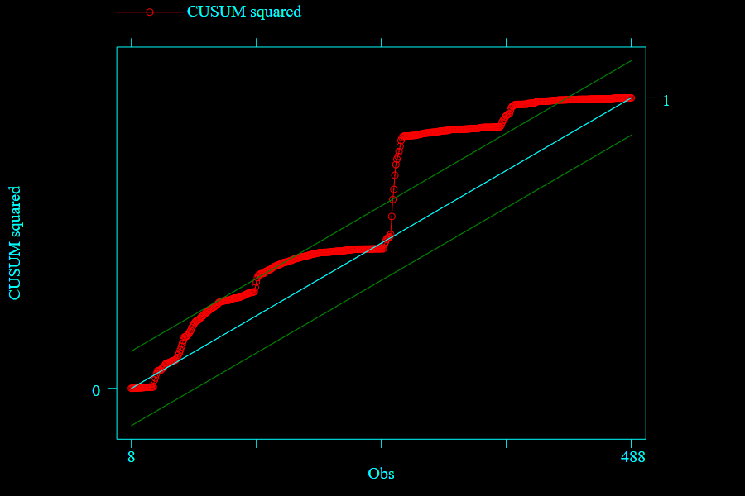
Source: Outcome from Stata14
Figure 3. CUSUMSQ test illustration
As being seen from Figure 3 that the external line appeared at the third quarter of the observation length, showing the same periods when the third (and forth) outbreak of COVID-19 pandemic started to plague in Ho Chi Minh city, causing thousands of infected cases and deaths (Vietnam Ministry of Health, 2021). That situation, in fact, was out of hand and forced the Government to implement directives 15 and 16. Therefore, in such periods, the stock market fluctuated in a relatively short duration before getting back to normalcy, this is to imply that any severe hits of COVID-19 outbreaks could bring up a short-term uncertainty to the model’s parameters, yet a stability is obviously soon after.
5. CONCLUSIONS
This study focuses on modeling the impact of COVID-19 pandemic, both in short-term and long-term, on Vietnam’s market returns volatility from 22nd January 2020 to the end of 2021 along with the returns in Brent crude oil price, the returns in national gold price and the returns in USD/VND exchange rate. The results confirm the short-term relationship between the pandemic and market returns volatility, additionally, the long-term effects reveal that COVID-19 cumulative infected cases pose no severe menace to Vietnam stock market since the uncertainty situation is fizzled out gradually. Besides, oil price and gold price could be market drivers when their effects in the long-run seem to outweigh that of COVID-19 cumulative cases.
This study indicates that the Government should pay more attention to the measures in order to maintain the successful process in preventing and ceasing the spreading of COVID-19, as a result, investors may seek for long-term horizons of investing to tolerate sudden shocks caused by the pandemic. By that, this also has policy implications. As long as COVID-19 still influences the volatility of market returns, the policy makers or market administrators should concern about a remedy for helping stabilize the market during the uncertainty, for example, The State Security of Commission of Vietnam may intensify the supervising activities so that profiteers are incapable of taking advantages of unauthorized information in the pandemic course. The fact that the Vietnam stock market over reacted in the short-term has been supported in the results of this study, thus, we indeed, need a coordination of the Stock Exchanges and Stock Information Centers so as to improve the trading activities and develop the market in the direction of immediately confronting the shocks on the financial environment. Nevertheless, as a result of the impact of oil price and gold price on the market volatility, investors should be careful with these alternative investing channels, for the reason that their influences may be distinctive between short-run and long-run periods.
5. REFERENCES
- Al-Awadhi, A. M., Alsaifi, K., Al-Awadhi, A., & Alhammadi, S. (2020). Death and contagious infectious diseases: Impact of the COVID-19 virus on stock market returns. Journal of Behavioral and Experimental Finance, 27, 100326.
- Alfaro, L., Chari, A., Greenland, A. N., & Schott, P. K. (2020). Aggregate and firm-level stock returns during pandemics, in real time. Retrieved from
- Anh, D. L. T., & Gan, C. (2020). The impact of the COVID-19 lockdown on stock market performance: evidence from Vietnam. Journal of Economic Studies, 48(4), 836-851. doi:10.1108/JES-06-2020-0312
- Ashraf, B. N. (2020). Stock markets’ reaction to COVID-19: Cases or fatalities? Research in International Business and Finance, 54, 101249.
- Baillie, R. T., & DeGennaro, R. P. (1990). Stock returns and volatility. Journal of Financial and Quantitative Analysis, 25(2), 203-214.
- Barro, R. J., Ursúa, J. F., & Weng, J. (2020). The coronavirus and the great influenza pandemic: Lessons from the “spanish flu” for the coronavirus’s potential effects on mortality and economic activity. Retrieved from
- Bora, D., & Basistha, D. (2021). The outbreak of COVID‐19 pandemic and its impact on stock market volatility: Evidence from a worst‐affected economy. Journal of Public Affairs, 2623.
- Camba, A. L., & Camba Jr, A. C. (2020). The effect of Covid-19 pandemic on the Philippine stock Exchange, Peso-Dollar rate and retail price of diesel. The Journal of Asian Finance, Economics and Business, 7(10), 543-553.
- Chaouachi, M., & Slim, C. (2020). Current covid-19 impact on Saudi stock market: Evidence from an ARDL model. International Journal of Accounting, Finance, Auditing, Management and Economics, 1(1), 1-13.
- Chaudhary, R., Bakhshi, P., & Gupta, H. (2020). Volatility in international stock markets: An empirical study during COVID-19. Journal of Risk and Financial Management, 13(9), 208.
- Chen, C.-D., Chen, C.-C., Tang, W.-W., & Huang, B.-Y. (2009). The positive and negative impacts of the SARS outbreak: A case of the Taiwan industries. The Journal of Developing Areas, 43(1), 281-293.
- Chương, P. H. (2020). Tác động của đại dịch Covid-19 đến nền kinh tế Việt Nam. Tạp chí Kinh tế và Phát triển, 274(4), 1-12.
- Dickey, D. A., & Fuller, W. A. (1981). Likelihood ratio statistics for autoregressive time series with a unit root. Econometrica: Journal of the Econometric Society, 1057-1072.
- Duttilo, P., Gattone, S. A., & Di Battista, T. (2021). Volatility Modeling: An Overview of Equity Markets in the Euro Area during COVID-19 Pandemic. Mathematics, 9(11), 1212.
- French, K. R., Schwert, G. W., & Stambaugh, R. F. (1987). Expected stock returns and volatility. Journal of financial economics, 19(1), 3-29.
- Gherghina, Ș. C., Armeanu, D. Ș., & Joldeș, C. C. (2021). COVID-19 Pandemic and Romanian Stock Market Volatility: A GARCH Approach. Journal of Risk and Financial Management, 14(8), 341. doi:10.3390/jrfm14080341
- Ha, B. T. T., La Quang, N., Mirzoev, T., Tai, N. T., Thai, P. Q., & Dinh, P. C. (2020). Combating the COVID-19 epidemic: experiences from Vietnam. International journal of environmental research and public health, 17(9), 3125.
- Hung, D. V., Hue, N. T. M., & Duong, V. T. (2021). The Impact of COVID-19 on Stock Market Returns in Vietnam. Journal of Risk and Financial Management, 14(9), 441.
- Kasman, S., Vardar, G., & Tunç, G. (2011). The impact of interest rate and exchange rate volatility on banks' stock returns and volatility: Evidence from Turkey. Economic Modelling, 28(3), 1328-1334.
- Koubâa, A. (2020). Understanding the COVID19 Outbreak: A Comparative Data Analytics and Study. Retrieved from
- Lê, V. T. (2020). Áp dụng mô hình GARCH trên thị trường chứng khoán Việt Nam. Tạp chí Công Thương, 20.
- Nguyen, C. T., Hai, P. T., & Nguyen, H. K. (2021). Stock market returns and liquidity during the COVID-19 outbreak: evidence from the financial services sector in Vietnam. Asian Journal of Economics and Banking, 5(3), 324-342. doi:10.1108/AJEB-06-2021-0070
- Pesaran, M. H., Shin, Y., & Smith, R. J. (1996). Testing for the'Existence of a Long-run Relationship'. Retrieved from
- Pesaran, M. H., Shin, Y., & Smith, R. J. (2001). Bounds testing approaches to the analysis of level relationships. Journal of applied econometrics, 16(3), 289-326.
- Phan, D. H. B., & Narayan, P. K. (2020). Country responses and the reaction of the stock market to COVID-19—A preliminary exposition. Emerging Markets Finance and Trade, 56(10), 2138-2150.
- Prabheesh, K., Padhan, R., & Garg, B. (2020). COVID-19 and the oil price–stock market nexus: Evidence from net oil-importing countries. Energy Research Letters, 1(2), 13745.
- Rabhi, A. (2020). Stock Market Vulnerability to the COVID-19 Pandemic: Evidence from Emerging Asian Stock Market. Journal of Advanced Studies in Finance (JASF), 11(22), 126-131.
- Sharma, S. S. (2020). A note on the Asian market volatility during the COVID-19 pandemic. Asian Economics Letters, 1(2), 17661.
- Singh, G., & Shaik, M. (2021). The Short-Term Impact of COVID-19 on Global Stock Market Indices. Contemporary Economics, 15(1), 1-19.
- Singhal, S., Choudhary, S., & Biswal, P. C. (2019). Return and volatility linkages among International crude oil price, gold price, exchange rate and stock markets: Evidence from Mexico. Resources Policy, 60, 255-261.
- Thiều, Q. N. T., & Xuân, T. H. (2021). COVID-19 và tỷ suất sinh lời của cổ phiếu ngành ngân hàng ở Việt Nam. Tạp chí Kinh tế và Phát triển(292), 2-11.
- Trương, Đ. L. (2014). Các nhân tố ảnh hưởng đến sự thay đổi giá của cổ phiếu: Các bằng chứng từ Sở Giao dịch Chứng khoán Thành Phố Hồ Chí Minh. Tạp chí Khoa học Trường Đại học Cần Thơ, 33, 72-78.
- Uddin, M., Chowdhury, A., Anderson, K., & Chaudhuri, K. (2021). The effect of COVID–19 pandemic on global stock market volatility: Can economic strength help to manage the uncertainty? Journal of Business Research, 128, 31-44.
- Van Nguyen, H., Van Hoang, M., Dao, A. T. M., Nguyen, H. L., Van Nguyen, T., Nguyen, P. T., . . . Gilmour, S. (2020). An adaptive model of health system organization and responses helped Vietnam to successfully halt the Covid‐19 pandemic: What lessons can be learned from a resource‐constrained country. The International journal of health planning management, 35(5), 988-992.
- Wardani, V. S., & Lahuddin, L. (2021). The Relationship between Current COVID-19 and Indonesia Stock Market: Evidence from ARDL Model. Jurnal Ekonomi Pembangunan, 19(1), 101-110.
- World Health Organization (2020), WHO Director-General’s Remarks at the Media Briefing
on 2019-nCoV on 11 February 2020. https://
www.who.int/dg/speeches/detail/who-director-general-s-remarks-at-the-media-briefingon-2019-ncov-on-11-february-2020.
- World Health Organization (2021), WHO Coronavirus disease (COVID-19) Weekly Epidemiological Update and Weekly Operational Update December 2021. https://www.who.int/emergencies/diseases/novel-coronavirus-2019/situation-reports.

